Name | Arsh Raina
UID no. | 2021600053
Experiment No. | 9

AIM: | Demonstrate the use of pointers to solve a given problem.
Program 1
PROBLEM STATEMENT : | Write a program to swap smallest and largest element in an array using pointers
PROGRAM: | 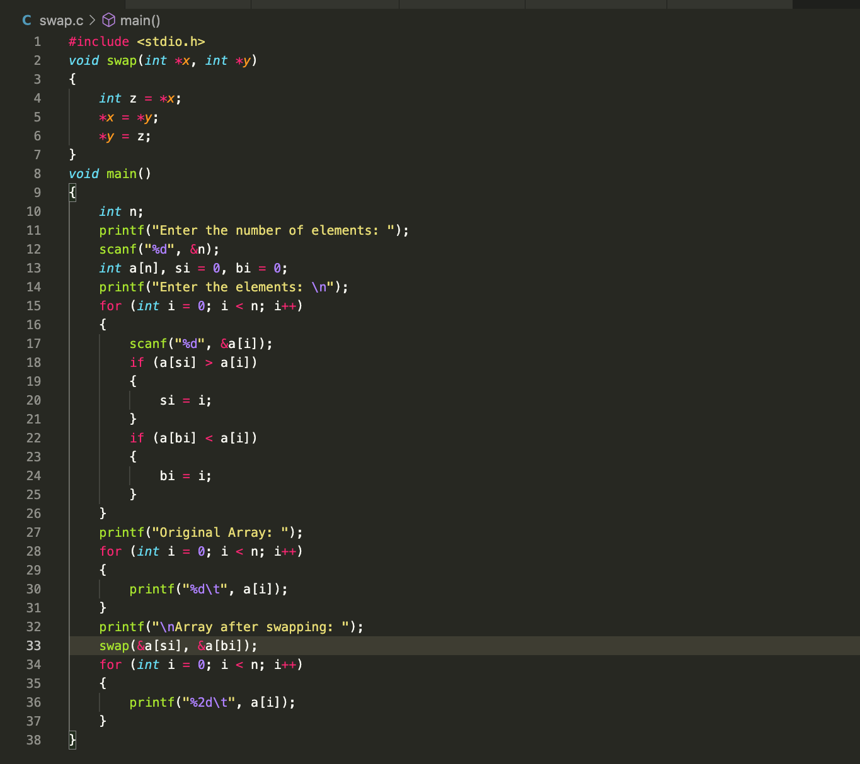
RESULT:
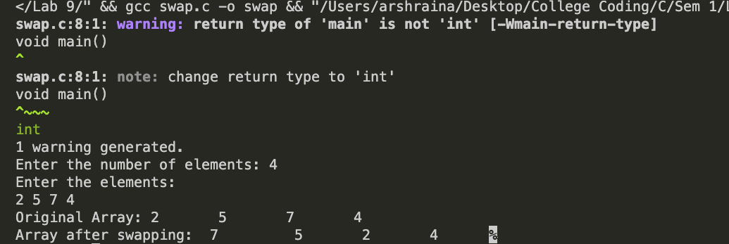
Program 2
PROBLEM STATEMENT : | Write a program to reverse the position of all elements in the array using pointers.
ALGORITHM: | - Start  - declare variables and pointers.  - Take input of array from the user.  - use for loops and switch position of largest no. and smallest number.  - use for loops and pointers to print the array after interchanging positions.  - Stop.
PROGRAM: | 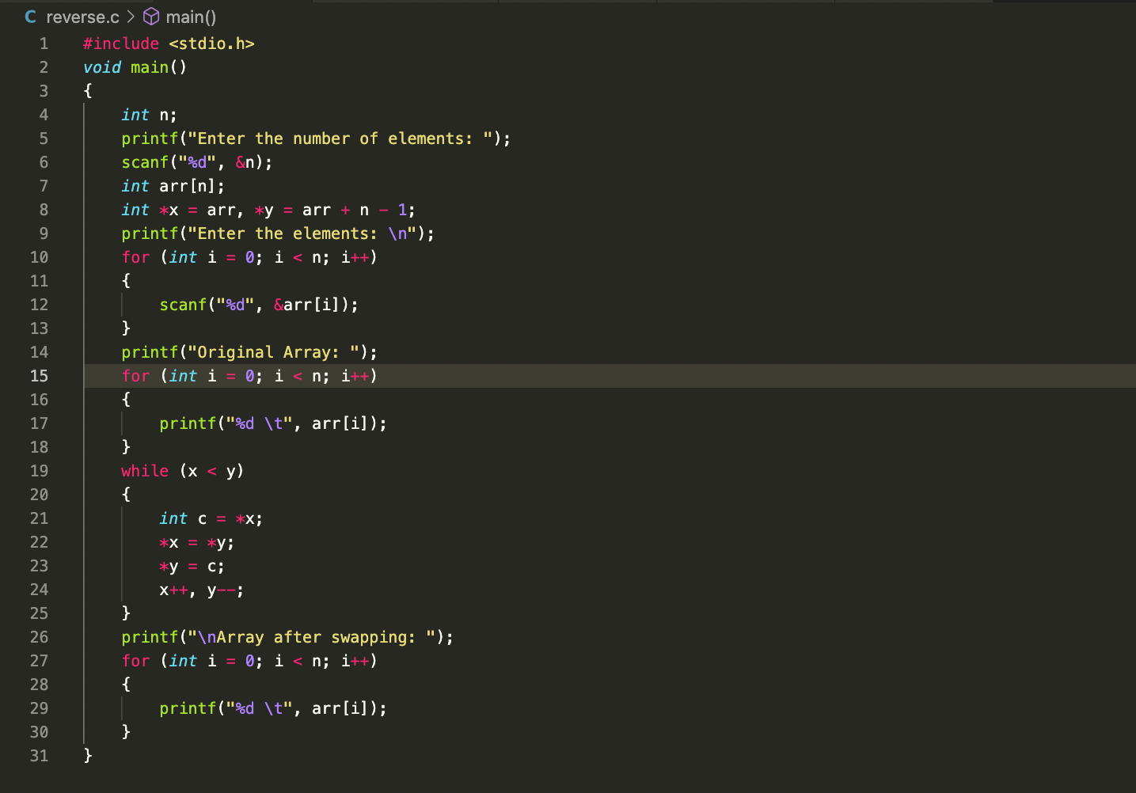
RESULT:
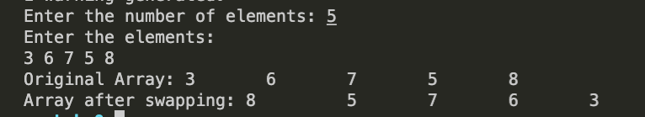
Program 3
PROBLEM STATEMENT: | Write a program to calculate the subtraction of matrices using pointers. Dimensions of the matrix will be decided by the user.
PROGRAM: | 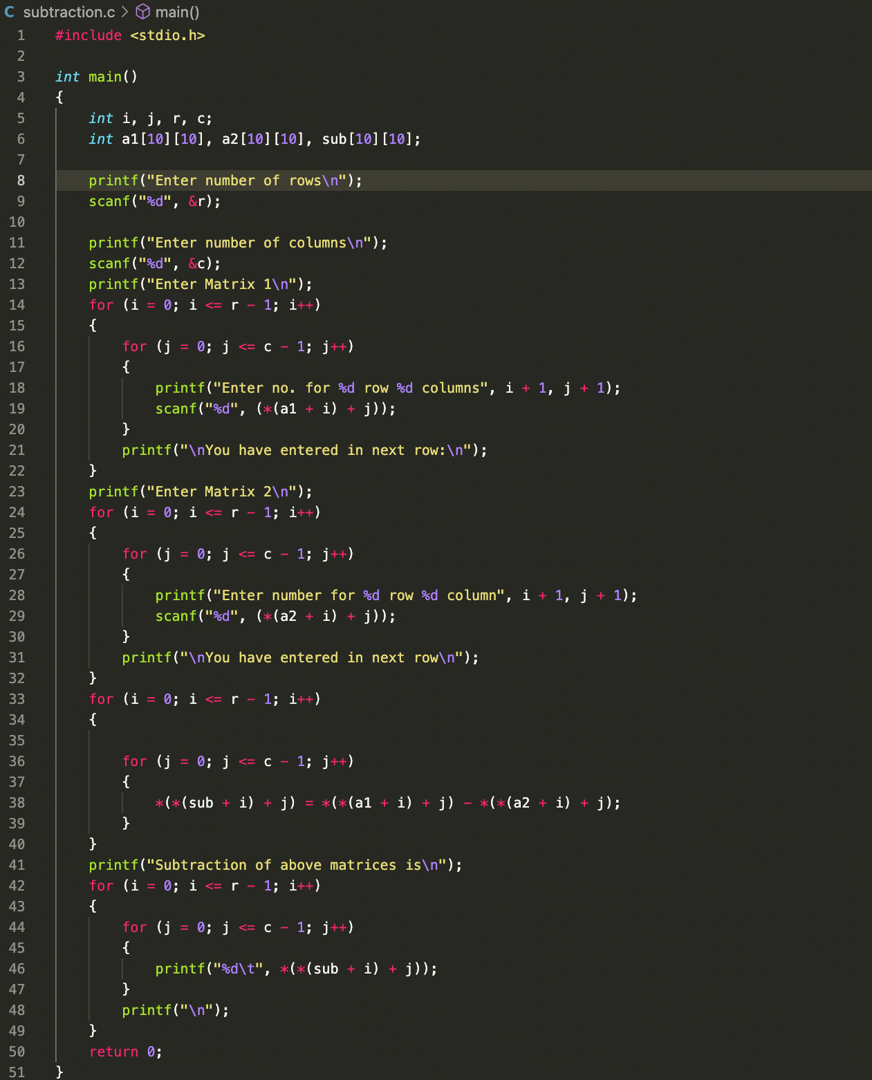
RESULT:
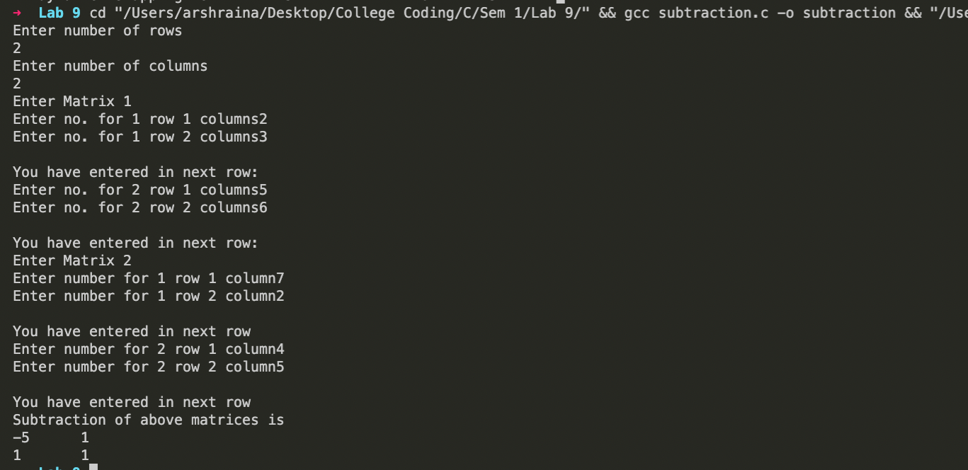
CONCLUSION: | Successfully demonstrated the use of pointers to solve a given problems.

